Fine Tune the model and use it in web-extension and verify the result generated based on the training.

Open https://api.testleaf.com/finetuning
Click on ‘Create’
Set the settings as below
Method: supervised fine tuning
Base model: gpt-4o-mini-2024-07-18
Training data : Upload the training_data_chat.jsonl file
HyperParameters
Batch Size: 1
Learning Rate Multiplier: 0.1
Number of Epoch: 4

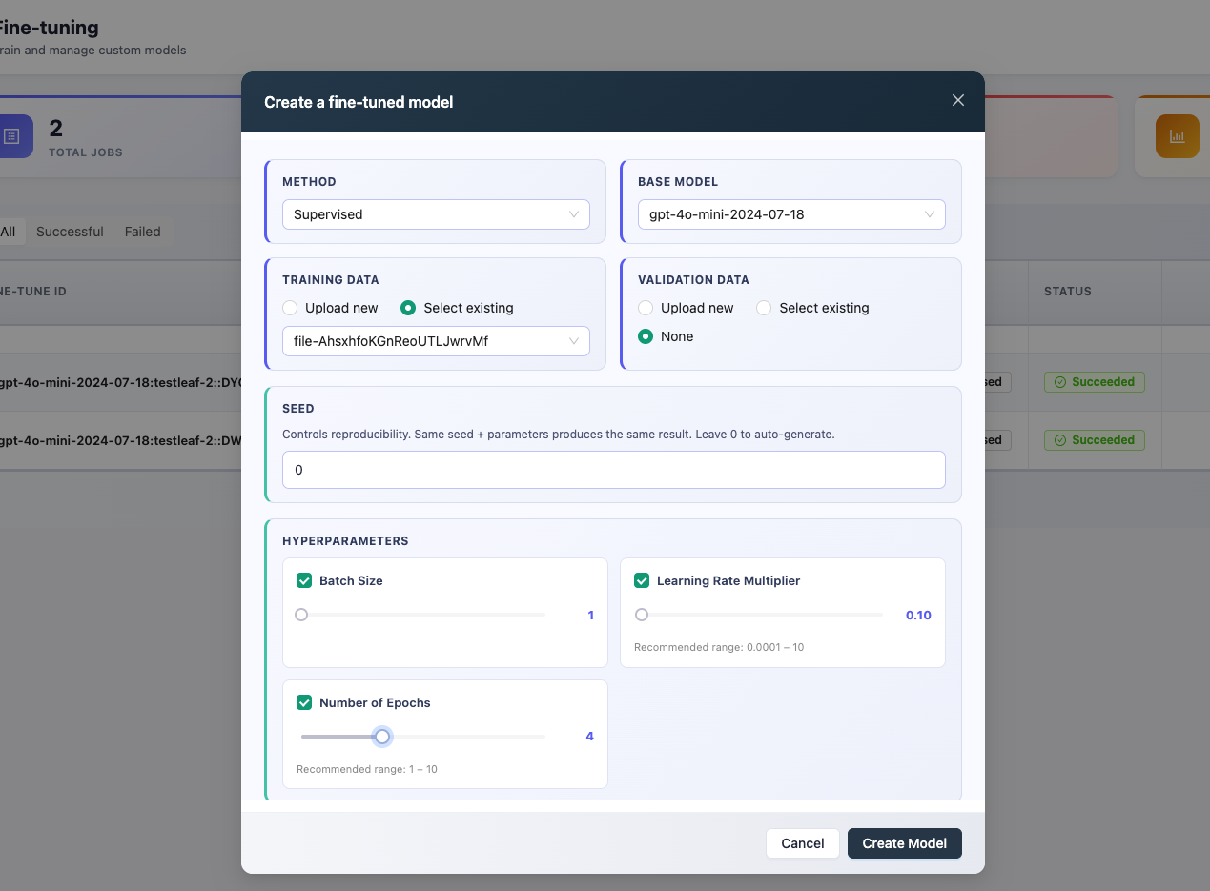
Click Create model.

Once Fine Tuning is done we will get a FuneTune ID

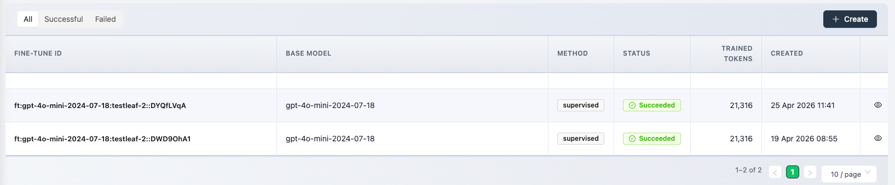

Copy the Fine Tune ID : ft:gpt-4o-mini-2024-07-18:testleaf-2::DYQfLVqA

Open AI Extender project in VsCode

Open popup.js file and navigate to modelsByProvider method

Add new component

testleaf: [
{value: 'ft:gpt-4o-mini-2024-07-18:testleaf-2::DYQfLVqA', label: 'Testleaf GPT-4o Mini (custom fine-tuned)'}
]

And Save.

Refresh the extension at chrome://extensions/

Open desired test page (amazon.in)
Click on extension icon → Settings
Select LLM Provider to Testleaf
Select Model: Testleaf GPT-4o Mini (custom fine-tuned)

Navigate back to https://api.testleaf.com/apikey and click on create key.
Provide a name for the API key and click on Create Key

A unique key would have been generated. Copy the key and paste it in the Tesleaf API key of the browser extension.

Navigate to code generator select desired options from Feature file or Page class (Feature file and Page class )

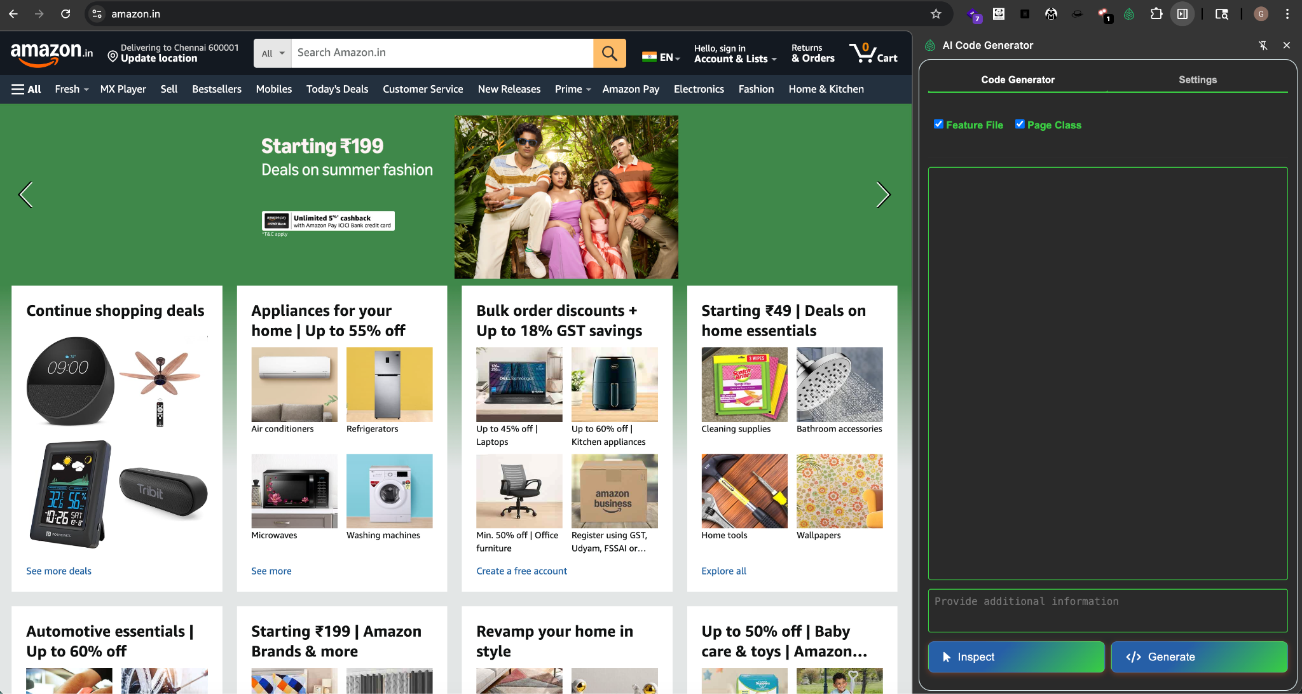
Click on Inspect and select the search bar
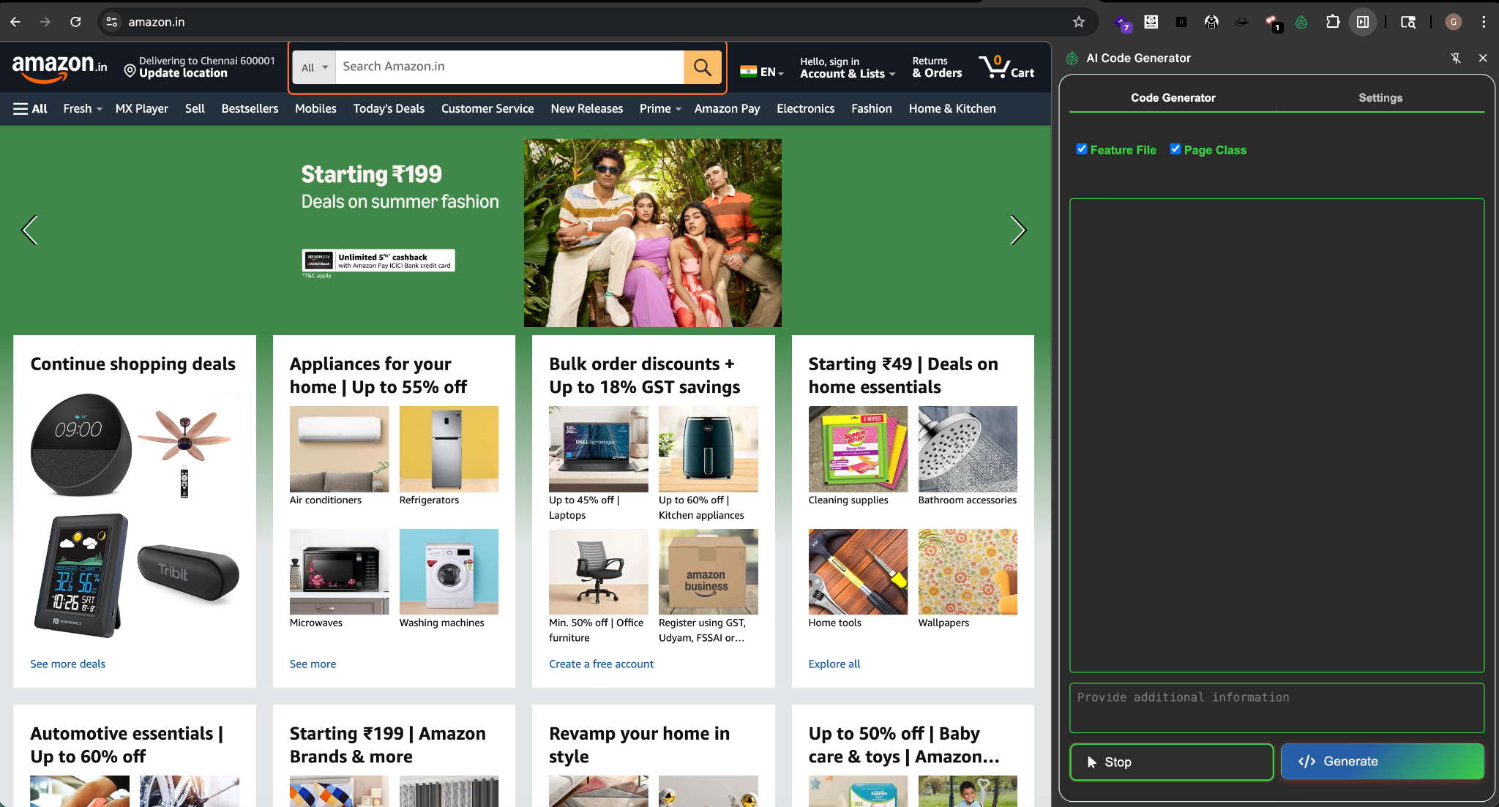
Click </>Generate.

Feature file and page class is generated
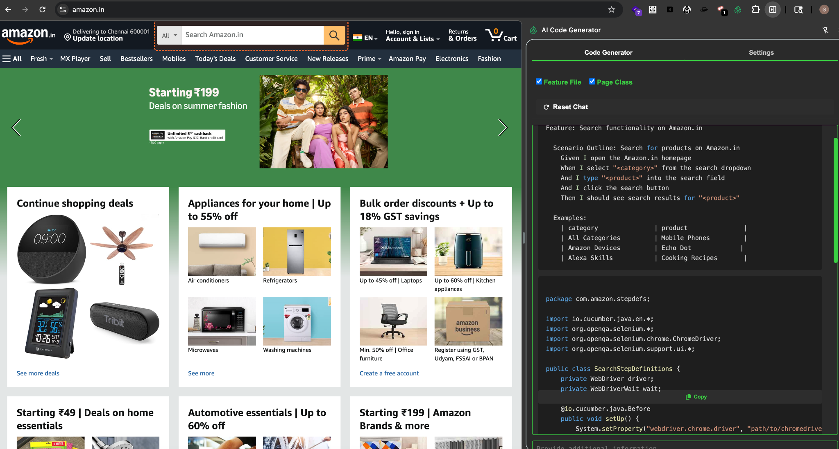

Code

Feature: Search functionality on Amazon.in

Scenario Outline: Search for products on Amazon.in
Given I open the Amazon.in homepage
When I select "<category>" from the search dropdown
And I type "<product>" into the search field
And I click the search button
Then I should see search results for "<product>"

Examples:
| category | product |
| All Categories | Mobile Phones |
| Amazon Devices | Echo Dot |
| Alexa Skills | Cooking Recipes |

Page Class

package com.amazon.stepdefs;

import io.cucumber.java.en.*;
import org.openqa.selenium.*;
import org.openqa.selenium.chrome.ChromeDriver;
import org.openqa.selenium.support.ui.*;

public class SearchStepDefinitions {
private WebDriver driver;
private WebDriverWait wait;

@io.cucumber.java.Before
public void setUp() {
System.setProperty("webdriver.chrome.driver", "path/to/chromedriver"); // Set path to your chromedriver
driver = new ChromeDriver();
wait = new WebDriverWait(driver, Duration.ofSeconds(10));
driver.manage().window().maximize();
}

@io.cucumber.java.After
public void tearDown() {
if (driver != null) driver.quit();
}

@Given("I open the Amazon.in homepage")
public void openAmazonHomepage() {
driver.get("https://www.amazon.in/");
}

@When("I select {string} from the search dropdown")
public void selectCategory(String category) {
WebElement dropdown = wait.until(ExpectedConditions.elementToBeClickable(By.id("searchDropdownBox")));
dropdown.click();
WebElement option = wait.until(ExpectedConditions.visibilityOfElementLocated(By.xpath("//option[contains(text(),'" + category + "')]")));
option.click();
}

@When("I type {string} into the search field")
public void enterProduct(String product) {
WebElement searchField = wait.until(ExpectedConditions.visibilityOfElementLocated(By.id("twotabsearchtextbox")));
searchField.sendKeys(product);
}

@When("I click the search button")
public void clickSearchButton() {
WebElement searchButton = wait.until(ExpectedConditions.elementToBeClickable(By.id("nav-search-submit-button")));
searchButton.click();
}

@Then("I should see search results for {string}")
public void verifySearchResults(String product) {
WebElement results = wait.until(ExpectedConditions.visibilityOfElementLocated(By.xpath("//span[contains(text(),'" + product + "')]")));
assert results.isDisplayed();
}
}

